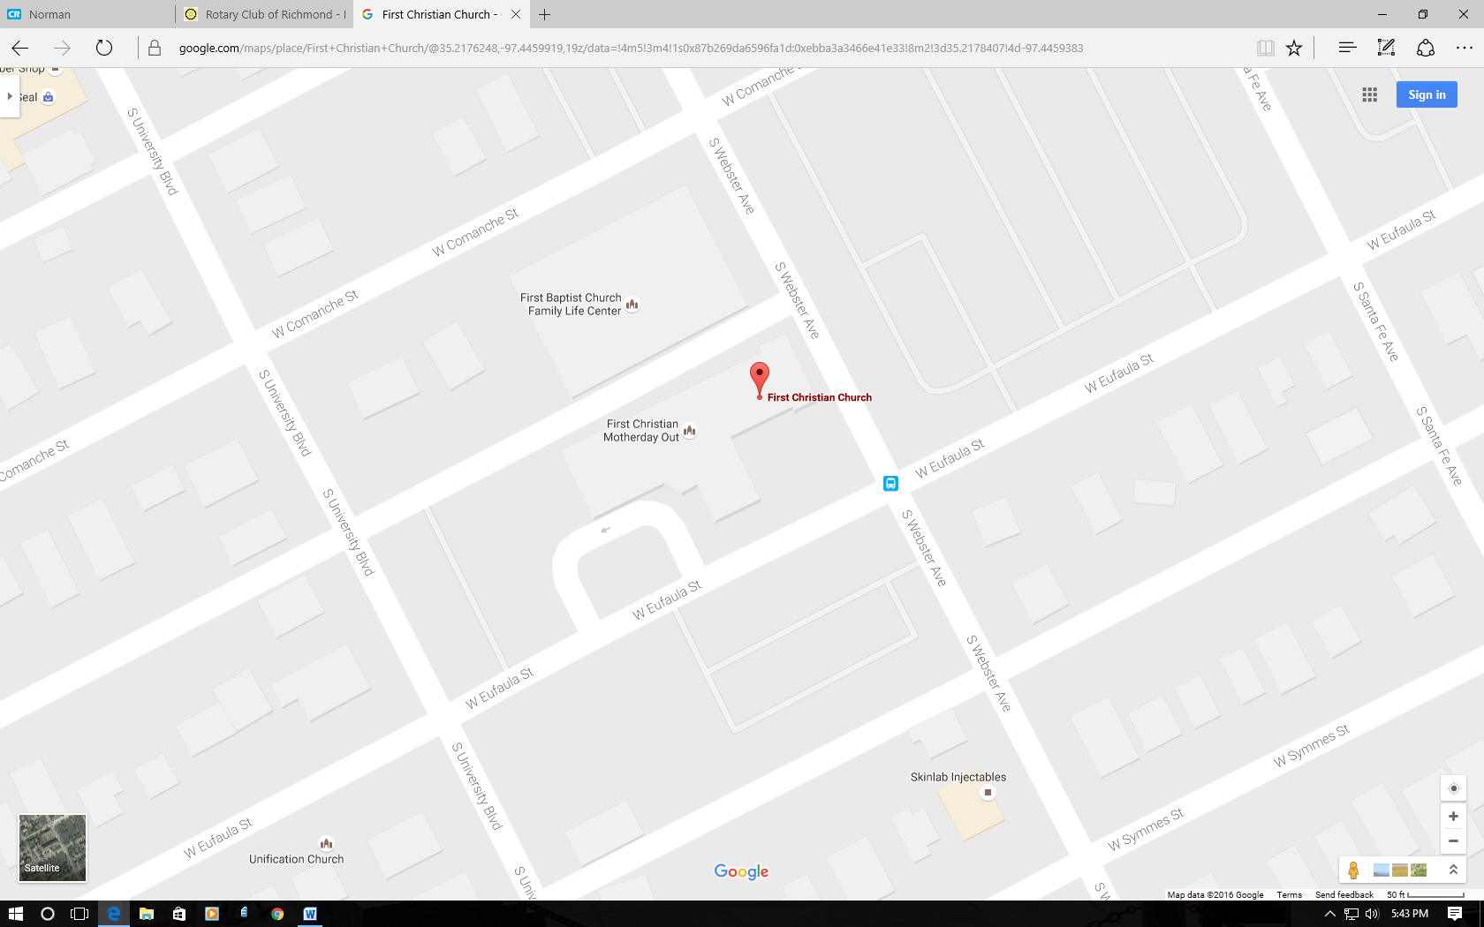

**Entrance**

**Parking**

**Parking**